DigitExtractor Mastery Assignment
Error log
Stefan S
CSE 3120 Object-Oriented Programming 1
(Num.java, DigitExtractor.java)
Describe the errors you’ve encountered while working on this assignment. What caused the error and how do you overcome the error?
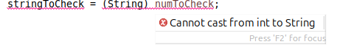
Eclipse tells me that I can’t just typecast from an int to a string. This was circumvented using the following method of the Integer class:

CONSISTENTLY, I must’ve had tens of outOfBoundsCheckFromTo errors as a result of this line.
The solution was to change the -1 to a +1. Because you will always subtract at least 1 from the start and end values, adding +1 to the end value makes sure that you aren’t returned an empty string.

For my main client code loop, I forgot to use two equality signs. This resulted in a loop which would never quit.

